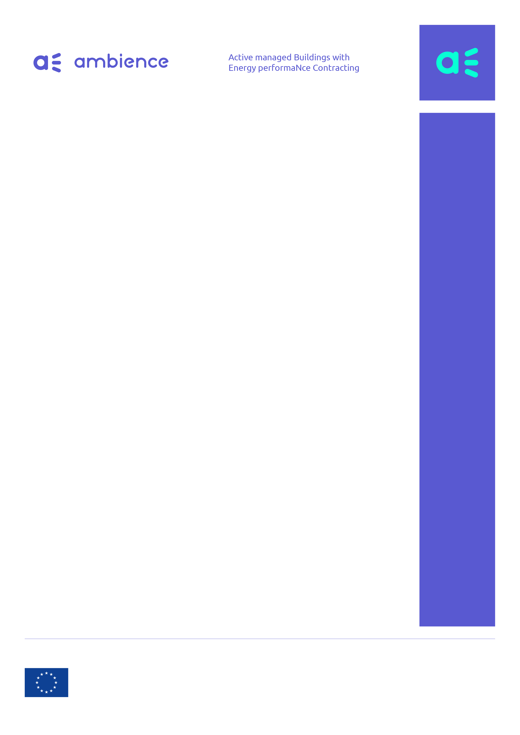

Survey for flexibility providers: Building EPC and demand response

The AmBIENCe Consortium

The AmBIENCe Consortium

The AmBIENCe Consortium

The AmBIENCe Consortium

The AmBIENCe Consortium

The AmBIENCe Consortium

The AmBIENCe Consortium

The AmBIENCe Consortium

April | 2020

JULY | 2019

JULY | 2019

JULY | 2019

JULY | 2019

JULY | 2019

JULY | 2019

JULY | 2019

This project has received funding from the European Union’s Horizon 2020 research and innovation programme under grant agreement No 768935.
Disclaimer: The sole responsibility for the content published on this website collection lies with the authors. It does not necessarily reflect the opinion of the Executive Agency for Small and Medium-sized Enterprises (EASME) or the European Commission (EC). EASME or the EC are not responsible for any use that may be made of the information contained therein.

This project has received funding from the European Union’s Horizon 2020 research and innovation programme under grant agreement No 768935.
Disclaimer: The sole responsibility for the content published on this website collection lies with the authors. It does not necessarily reflect the opinion of the Executive Agency for Small and Medium-sized Enterprises (EASME) or the European Commission (EC). EASME or the EC are not responsible for any use that may be made of the information contained therein.

This project has received funding from the European Union’s Horizon 2020 research and innovation programme under grant agreement No 768935.
Disclaimer: The sole responsibility for the content published on this website collection lies with the authors. It does not necessarily reflect the opinion of the Executive Agency for Small and Medium-sized Enterprises (EASME) or the European Commission (EC). EASME or the EC are not responsible for any use that may be made of the information contained therein.

This project has received funding from the European Union’s Horizon 2020 research and innovation programme under grant agreement No 768935.
Disclaimer: The sole responsibility for the content published on this website collection lies with the authors. It does not necessarily reflect the opinion of the Executive Agency for Small and Medium-sized Enterprises (EASME) or the European Commission (EC). EASME or the EC are not responsible for any use that may be made of the information contained therein.

This project has received funding from the European Union’s Horizon 2020 research and innovation programme under grant agreement No 768935.
Disclaimer: The sole responsibility for the content published on this website collection lies with the authors. It does not necessarily reflect the opinion of the Executive Agency for Small and Medium-sized Enterprises (EASME) or the European Commission (EC). EASME or the EC are not responsible for any use that may be made of the information contained therein.

This project has received funding from the European Union’s Horizon 2020 research and innovation programme under grant agreement No 768935.
Disclaimer: The sole responsibility for the content published on this website collection lies with the authors. It does not necessarily reflect the opinion of the Executive Agency for Small and Medium-sized Enterprises (EASME) or the European Commission (EC). EASME or the EC are not responsible for any use that may be made of the information contained therein.

This project has received funding from the European Union’s Horizon 2020 research and innovation programme under grant agreement No 768935.
Disclaimer: The sole responsibility for the content published on this website collection lies with the authors. It does not necessarily reflect the opinion of the Executive Agency for Small and Medium-sized Enterprises (EASME) or the European Commission (EC). EASME or the EC are not responsible for any use that may be made of the information contained therein.

This project has received funding from the European Union’s Horizon 2020 research and innovation programme under grant agreement No 768935.
Disclaimer: The sole responsibility for the content published on this website collection lies with the authors. It does not necessarily reflect the opinion of the Executive Agency for Small and Medium-sized Enterprises (EASME) or the European Commission (EC). EASME or the EC are not responsible for any use that may be made of the information contained therein.

Interviewee instructions

Dear interviewee,

Thank you very much for taking the time to fill in this questionnaire. In total, it should not take more than 15 minutes to fill in the entire questionnaire.

The goal of this questionnaire is to better understand how buildings currently make use of active control in buildings, and whether this active control is already linked to demand response, possibly in the context of EPC-contracts. This is important because to reduce building emissions, next to lowering consumption, we need to electrify and be smarter in relation to when we consume. Smart Demand Response schemes that steer consumption to times when the electricity carbon intensity is low, can make EPC much more effective.

The questionnaire contains simple yes/no tick boxes such as: ☐. By clicking on them with your mouse, you tick the box (= “yes”). Furthermore, there are some open questions which for which we leave free space in blue where you can answer.

If there are any questions, please feel free to send your concerns or questions to info@ambience-project.eu

After filling in the questionnaire, please send it back to info@ambience-project.eu

Kind regards,

The Ambience Consortium
http://ambience-project.eu/

General information

What is your name?
In which organization are you active?
In which country are you active?
What is your role in the organization?

- CURRENT STATUS OF ACTIVE CONTROL IN BUILDINGS

  - What measures are you using today and in which buildings?

 | Residential Buildings | Commercial Buildings (Office buildings, Retail, Hotels, Banks) | Public Buildings: (Government, Local authorities, Schools…), | Is this done in the context of an EPC-contract?
Do you have projects in these buildings? | ☐Yes  ☐No (you don’t have to fill in this column) | ☐Yes  ☐No (you don’t have to fill in this column) | ☐Yes  ☐No (you don’t have to fill in this column) | ☐Yes  ☐No
Passive Energy Efficiency measures: insulation | ☐ Never  ☐ <25% of the cases  ☐ 25-50% of the cases  ☐ 50-75% of the cases  ☐ >75% of the cases | ☐ Never  ☐ <25% of the cases  ☐ 25-50% of the cases  ☐ 50-75% of the cases  ☐ >75% of the cases | ☐ Never  ☐ <25% of the cases  ☐ 25-50% of the cases  ☐ 50-75% of the cases  ☐ >75% of the cases | ☐Yes  ☐No
Adding RES generation (PV…) | ☐ Never  ☐ <25% of the cases  ☐ 25-50% of the cases  ☐ 50-75% of the cases  ☐ >75% of the cases | ☐ Never  ☐ <25% of the cases  ☐ 25-50% of the cases  ☐ 50-75% of the cases  ☐ >75% of the cases | ☐ Never  ☐ <25% of the cases  ☐ 25-50% of the cases  ☐ 50-75% of the cases  ☐ >75% of the cases | ☐Yes  ☐No
Replacing gas by electric appliances (e.g. heat pump…) | ☐ Never  ☐ <25% of the cases  ☐ 25-50% of the cases  ☐ 50-75% of the cases  ☐ >75% of the cases | ☐ Never  ☐ <25% of the cases  ☐ 25-50% of the cases  ☐ 50-75% of the cases  ☐ >75% of the cases | ☐ Never  ☐ <25% of the cases  ☐ 25-50% of the cases  ☐ 50-75% of the cases  ☐ >75% of the cases | ☐Yes  ☐No
Adding/increasing storage (electric, thermal) | ☐ Never  ☐ <25% of the cases  ☐ 25-50% of the cases  ☐ 50-75% of the cases  ☐ >75% of the cases | ☐ Never  ☐ <25% of the cases  ☐ 25-50% of the cases  ☐ 50-75% of the cases  ☐ >75% of the cases | ☐ Never  ☐ <25% of the cases  ☐ 25-50% of the cases  ☐ 50-75% of the cases  ☐ >75% of the cases | ☐Yes  ☐No
Active/automated control | ☐ Never  ☐ <25% of the cases  ☐ 25-50% of the cases  ☐ 50-75% of the cases  ☐ >75% of the cases | ☐ Never  ☐ <25% of the cases  ☐ 25-50% of the cases  ☐ 50-75% of the cases  ☐ >75% of the cases | ☐ Never  ☐ <25% of the cases  ☐ 25-50% of the cases  ☐ 50-75% of the cases  ☐ >75% of the cases | ☐Yes  ☐No

  - In case you add storage: what type of storage do you use?

☐ Stationary battery
☐ Hot water vessels for sanitary hot water of space heating
☐ EV charging poles
☐ Other:

  - If you indicated previously that you are incorporating active/automated control measures: what is the driving factor?
☐ Improved comfort
☐ Are you offering non-fixed comfort boundaries
☐ e.g. day/night
☐ e.g. weekday/weekend
☐ Other:
☐ Are you offering stretchable comfort boundaries (e.g. broader boundaries if the incentives are high enough)
☐ Is the end-user in control of setting and changing the dynamic and/or stretchable comfort boundaries
☐ More Energy saving (less kWh)
☐ More Cost savings (less €)
☐ More Emission savings (less CO₂)
☐ Other:

  - If you indicated previously that you are incorporating active/automated control measures, on which technologies are they applied and how frequently?

 | Never | Rarely | Regularly | Frequently
Heating | ☐ | ☐ | ☐ | ☐
Cooling | ☐ | ☐ | ☐ | ☐
Ventilation | ☐ | ☐ | ☐ | ☐
Compressed air | ☐ | ☐ | ☐ | ☐
Hot water production | ☐ | ☐ | ☐ | ☐
Screens/blinds | ☐ | ☐ | ☐ | ☐
Lighting | ☐ | ☐ | ☐ | ☐
Batteries | ☐ | ☐ | ☐ | ☐
EV Charging poles | ☐ | ☐ | ☐ | ☐
Other… | ☐ | ☐ | ☐ | ☐

  - If you indicated previously that you are incorporating active/automated control measures: what type are you using?
☐ Time(r) based
Please explain what and how you are doing this?

☐ Trigger/Event/Measurement based (e.g. triggered by a measurement solar intensity, occupancy/presence, temperature, PV generation…)
Please explain what and how you are doing this?

☐ ‘smart’ (e.g. using forecasts, models, …)
Please explain what and how you are doing this?

☐ Other:
Please explain what and how you are doing this?

  - If you indicated previously that you are NOT incorporating active/automated control measures: why not?
☐ Don’t know about it / Not familiar with it
☐ Not allowed (regulation)
☐ Not enough value/no business cases
☐ Too complex/technical challenges
☐ Other:

- USE OF DEMAND RESPONSE IN BUILDING AND LINKAGES WITH EPC

  - What demand response business cases are possible for your buildings and which one are you leveraging today? Please indicate if you are already making use of them today, and if not, indicate why you are not.

 | Which positive business cases are possible according to you? | Are you making use of this business case? | Could this business case be possible in 3 to 5 years? | Is it a Pilot or Commercial
Implicit DR (tariff structure based)
Dynamic tariffs (Day/Night, more complex) | ☐ Yes  ☐ No | ☐ Yes  ☐ No | ☐ Yes  ☐ No | ☐ Pilot  ☐ Commercial
 | Please explain why or why not you are making use of this business case? In case you are making use of it, please also explain the business case in more detail.
Different Injection/Consumption tariffs | ☐ Yes  ☐ No | ☐ Yes  ☐ No | ☐ Yes  ☐ No | ☐ Pilot  ☐ Commercial
 | Please explain why or why not you are making use of this business case? In case you are making use of it, please also explain the business case in more detail.
Capacity tariffs | ☐ Yes  ☐ No | ☐ Yes  ☐ No | ☐ Yes  ☐ No | ☐ Pilot  ☐ Commercial
 | Please explain why or why not you are making use of this business case? In case you are making use of it, please also explain the business case in more detail.
Other… | ☐ Yes  ☐ No | ☐ Yes  ☐ No | ☐ Yes  ☐ No | ☐ Pilot  ☐ Commercial
 | Please explain why or why not you are making use of this business case? In case you are making use of it, please also explain the business case in more detail.

 | Which positive business cases are possible according to you? | Are you making use of this business case? | Could this business case be possible in 3 to 5 years? | Is it a Pilot or Commercial
Explicit DR (on-request services)
 | ☐ Yes  ☐ No | ☐ Yes  ☐ No | ☐ Yes  ☐ No | ☐ Pilot  ☐ Commercial
Please explain why or why not you are making use of this business case?

In case you are making use of it, please also explain the business case in more detail.

In case you are making use of it, please also explain for whom.

  - What are the business models you have developed or are planning to develop and use, that combine energy efficiency and/or EPC on one hand and DR and flexibility on the other hand?

  - How are you taking into account flexibility in your business models? To what extent are you already offering fixed/guaranteed savings with regard to Demand Response to a client (as part of the business model)?

  - In case you are already offering fixed savings with regard to Demand Response, how do you internalize the risks or how do you make them explicit to the clients? What are potential problems for you or the client?

  - In case there are any other comments you want to share with us, feel free to use the space below!

Thank you very much for your help and contributions!

