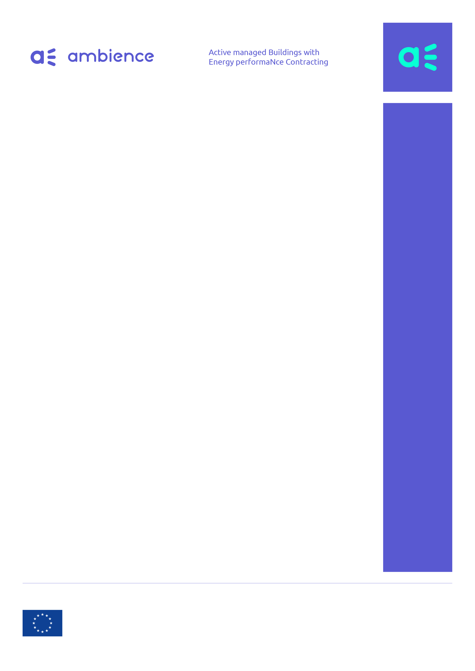

Survey for flexibility requesters: using flexibility from buildings for demand response services

The AmBIENCe Consortium

The AmBIENCe Consortium

The AmBIENCe Consortium

The AmBIENCe Consortium

The AmBIENCe Consortium

The AmBIENCe Consortium

The AmBIENCe Consortium

The AmBIENCe Consortium

March | 2020

JULY | 2019

JULY | 2019

JULY | 2019

JULY | 2019

JULY | 2019

JULY | 2019

JULY | 2019

This project has received funding from the European Union’s Horizon 2020 research and innovation programme under grant agreement No 768935.
Disclaimer: The sole responsibility for the content published on this website collection lies with the authors. It does not necessarily reflect the opinion of the Executive Agency for Small and Medium-sized Enterprises (EASME) or the European Commission (EC). EASME or the EC are not responsible for any use that may be made of the information contained therein.

This project has received funding from the European Union’s Horizon 2020 research and innovation programme under grant agreement No 768935.
Disclaimer: The sole responsibility for the content published on this website collection lies with the authors. It does not necessarily reflect the opinion of the Executive Agency for Small and Medium-sized Enterprises (EASME) or the European Commission (EC). EASME or the EC are not responsible for any use that may be made of the information contained therein.

This project has received funding from the European Union’s Horizon 2020 research and innovation programme under grant agreement No 768935.
Disclaimer: The sole responsibility for the content published on this website collection lies with the authors. It does not necessarily reflect the opinion of the Executive Agency for Small and Medium-sized Enterprises (EASME) or the European Commission (EC). EASME or the EC are not responsible for any use that may be made of the information contained therein.

This project has received funding from the European Union’s Horizon 2020 research and innovation programme under grant agreement No 768935.
Disclaimer: The sole responsibility for the content published on this website collection lies with the authors. It does not necessarily reflect the opinion of the Executive Agency for Small and Medium-sized Enterprises (EASME) or the European Commission (EC). EASME or the EC are not responsible for any use that may be made of the information contained therein.

This project has received funding from the European Union’s Horizon 2020 research and innovation programme under grant agreement No 768935.
Disclaimer: The sole responsibility for the content published on this website collection lies with the authors. It does not necessarily reflect the opinion of the Executive Agency for Small and Medium-sized Enterprises (EASME) or the European Commission (EC). EASME or the EC are not responsible for any use that may be made of the information contained therein.

This project has received funding from the European Union’s Horizon 2020 research and innovation programme under grant agreement No 768935.
Disclaimer: The sole responsibility for the content published on this website collection lies with the authors. It does not necessarily reflect the opinion of the Executive Agency for Small and Medium-sized Enterprises (EASME) or the European Commission (EC). EASME or the EC are not responsible for any use that may be made of the information contained therein.

This project has received funding from the European Union’s Horizon 2020 research and innovation programme under grant agreement No 768935.
Disclaimer: The sole responsibility for the content published on this website collection lies with the authors. It does not necessarily reflect the opinion of the Executive Agency for Small and Medium-sized Enterprises (EASME) or the European Commission (EC). EASME or the EC are not responsible for any use that may be made of the information contained therein.

This project has received funding from the European Union’s Horizon 2020 research and innovation programme under grant agreement No 768935.
Disclaimer: The sole responsibility for the content published on this website collection lies with the authors. It does not necessarily reflect the opinion of the Executive Agency for Small and Medium-sized Enterprises (EASME) or the European Commission (EC). EASME or the EC are not responsible for any use that may be made of the information contained therein.

Interviewee instructions

Dear interviewee,

Thank you very much for taking the time to fill in this questionnaire. In total, it should not take more than 10 minutes to fill in the entire questionnaire.

This research is done in the context of the AmBIENCe project that investigates to which extent and how buildings can provide flexibility (for demand response) in the context of EPC-contracts. This is important because in order to reduce building emissions, next to lowering consumption, we need to electrify and be smarter in relation to when we consume. Smart Demand Response schemes that steer consumption to times when the electricity carbon intensity is low, can make EPC much more effective. Additionally, flexibility services can be offered to mitigate issues that may result from the increasing amount of distributed vRES and electrification.

This specific questionnaire is aimed at organizations who may be in need for flexibility. It collects information to understand to which extent these organizations are using or are interested in /are considering to use flexibility from buildings.

The questionnaire includes simple yes/no tick boxes such as: ☐. By clicking on them you tick the box. Furthermore, there are some open questions for which we leave open space in blue where you can answer.

If there are any questions, please feel free to send your concerns or questions to info@ambience-project.eu.

After filling in the questionnaire, please send it back to info@ambience-project.eu.

Kind regards,

The AmBIENCe Consortium
http://ambience-project.eu/

General information

What is your name?
In which organization are you active?
In which country are you active?
What is your role in the organization?

- Are you using or would you be interested in using flexibility provided by BUILDINGS, if this would be ‘ready-to-use’ flexibility (that is responding to your technical requirements)?
☐ Yes ☐ Maybe ☐ No ☐ Don’t know

  - If “No”, why not?

☐ No need for Flexibility

☐ No confidence in Demand Side Flexibility provided by BUILDINGS
Which specific barriers do you see that prevent its use?

  - If “Yes” or “Maybe”,
    - What are/would you consider to be the main ‘ready-to-use’ criteria?
☐ Reliability (i.e. what is offered - and subsequently ordered/requested - is actually delivered/
activated)
Please explain in relation to your intended use (e.g. congestion management, portfolio balancing, …) what would be the most relevant metric? % tolerable deviation? In terms of energy consumption or power profile or combination? Etc.

☐ Aggregability (i.e. easy to aggregate, so that the volume is high enough)
Please explain what would be the minimum volume necessary:

☐ Settlement-ability (i.e. easy to verify what was ordered/requested versus what was delivered/captivated to facilitate financial settlements)

☐ Technical Standardization (i.e. uniform way to interact with the flex providing buildings)

☐ Other: please explain.

    - How do/would you benefit from flexibility? Which business models do you see (e.g. what would you use it for, what type of flexibility would you need)?

    - How often do/would you need flexibility?
☐ Daily ☐ Weekly ☐ Monthly ☐ Occasionally
Please explain:

    - What reward/incentive scheme do you use/would you prefer?
☐ Pay for capacity/availability (i.e. reservation) ☐ Pay for activation after reservation☐ Combination of reservation and activation payments
☐ No reservation, only pay for activation ☐ Other incentives
Please explain:

    - Would it help if buildings themselves provide information on their planned flexibility to facilitate your decisions?
☐ Yes ☐ No
Please explain.

    - What other practical considerations are important to take into account?

  - If “Don’t know”, would you like to know more about flexibility in buildings?
☐ Yes ☐ No
Please explain.

- If you are already making use of flexibility from buildings:
  - Is this at pilot or at commercial level?
☐ Pilot ☐ Commercial

  - Which type of buildings are involved? Please explain (E.g. public, commercial or residential buildings? Clusters of buildings? Of what size?)

  - Which type of services do these buildings deliver? How do they help you? (Congestion management, portfolio balancing…)

- If you are considering/planning to make use of flexibility from buildings:

  - Will this be a pilot or a commercial project?
☐ Pilot ☐ Commercial

  - When would this start?
☐ Within the next year ☐ Within the next 3 year ☐ Later

  - Which type of buildings will be involved? Please explain (E.g. public, commercial or residential buildings? Clusters of buildings? Of what size?)

  - Which type of services will these buildings deliver? How do they help you? (Congestion management, portfolio balancing…)

- If you have specific comments, feel free to leave these here.

Thank you very much for your help and contributions!

